Programming Concepts  
Week 8 **Pass** Submission Tasks Template

Student ID: _____Mario Stavreski________________

Student Name: _______103055993_______________________

## Pass Task 4 HTML code

Paste the HTML code of the web page here.

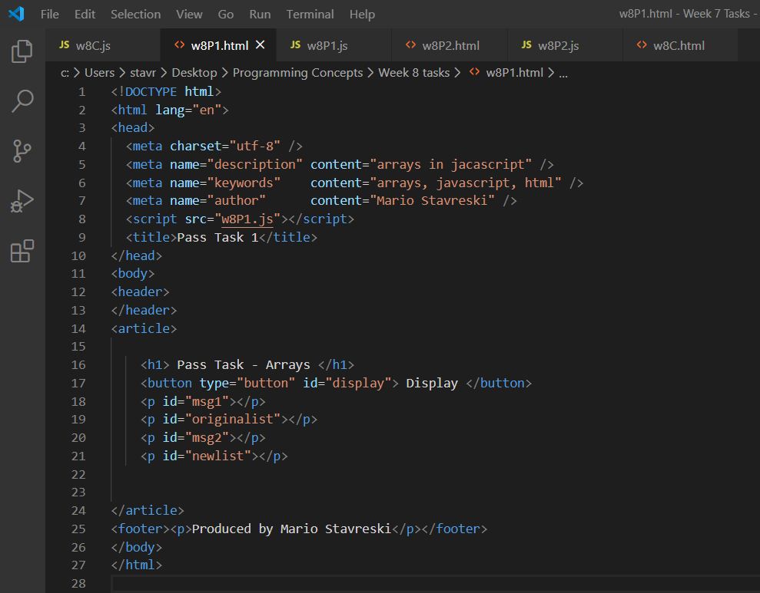

## Pass Task 4 JavaScript code

Paste the JavaScript code of the same page here.

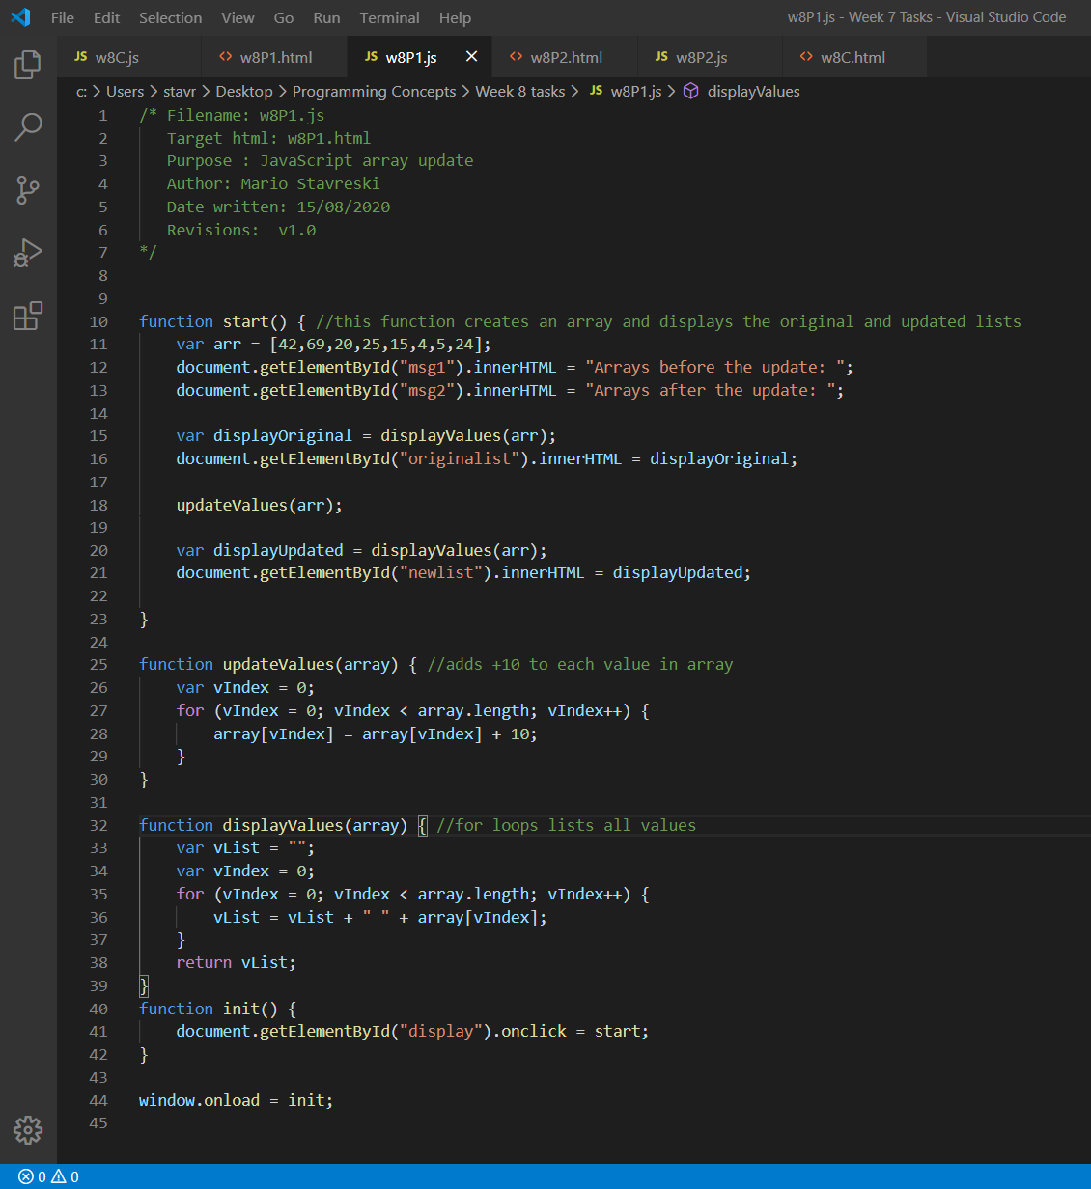

## Pass Task 4 web page testing

Paste the screen captures of your testing web page here.

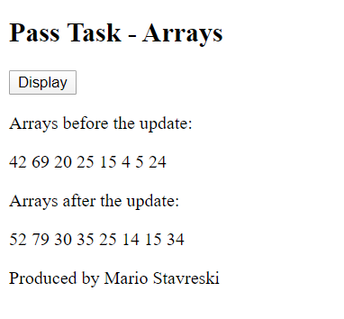

## Pass Task 10 HTML code

Paste the HTML code of the web page here.

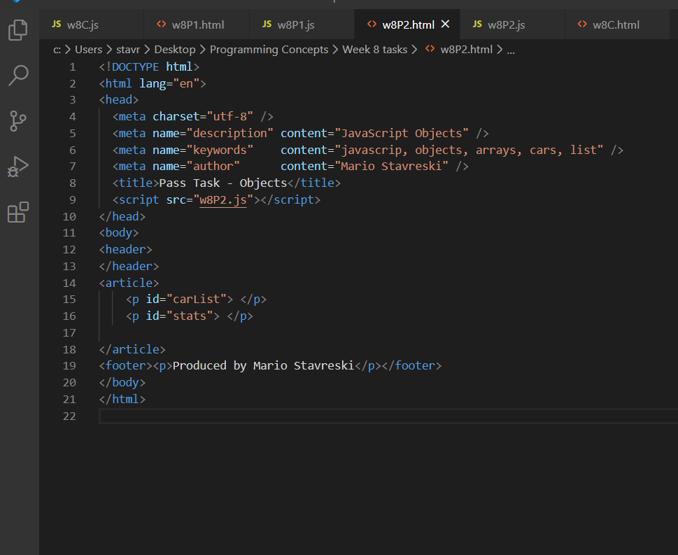

## Pass Task 10 JavaScript code

Paste the JavaScript code of the same page here.

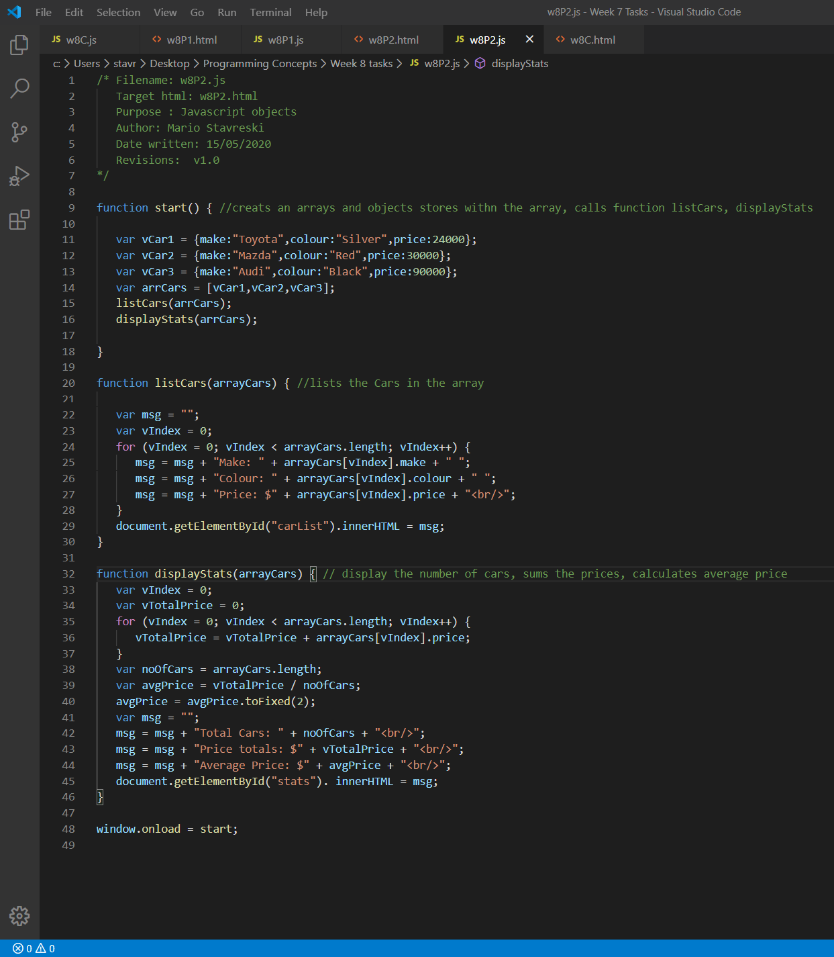

## Pass Task 10 web page testing

Paste the screen captures of your testing web page here. 